Nama : Rival Fauzi Rahman

Kelas : TE (TKK)

NIM : 1207070108

Hasil screenshot Praktikum Pengolahan Citra Digital Modul 5

1. Praktikum 05 - Brightness, Contrass, Autolevel

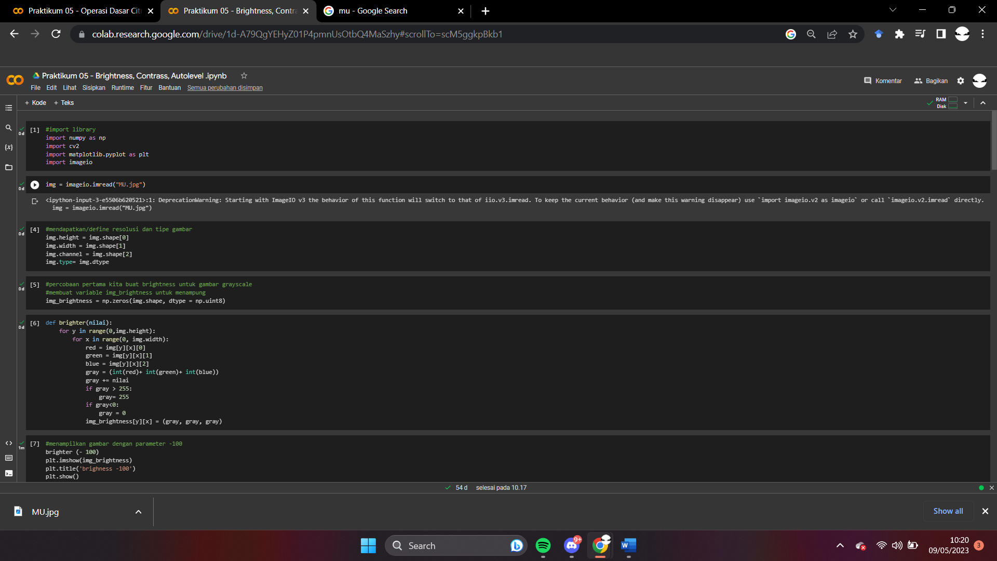

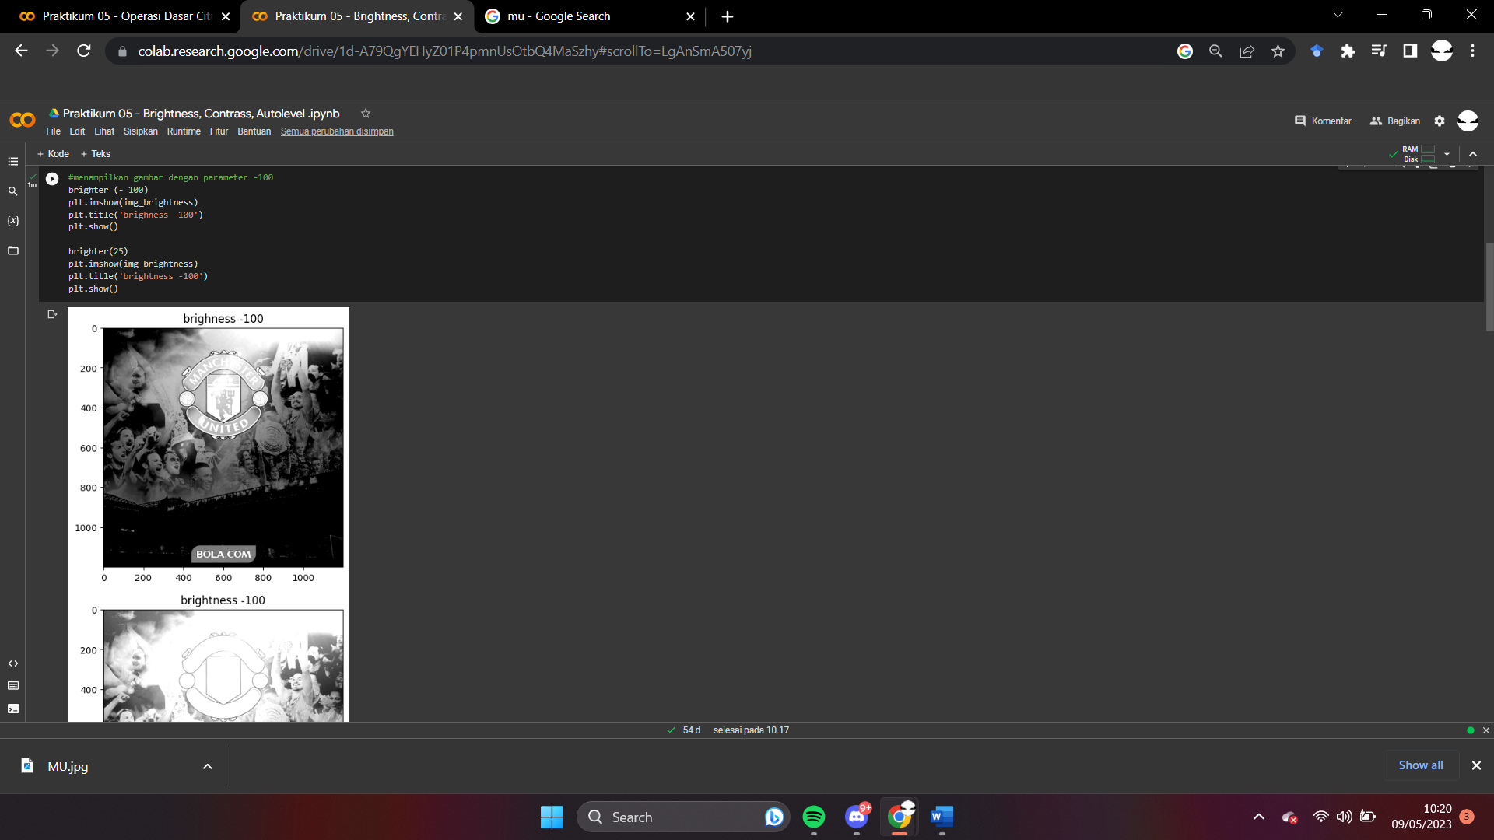

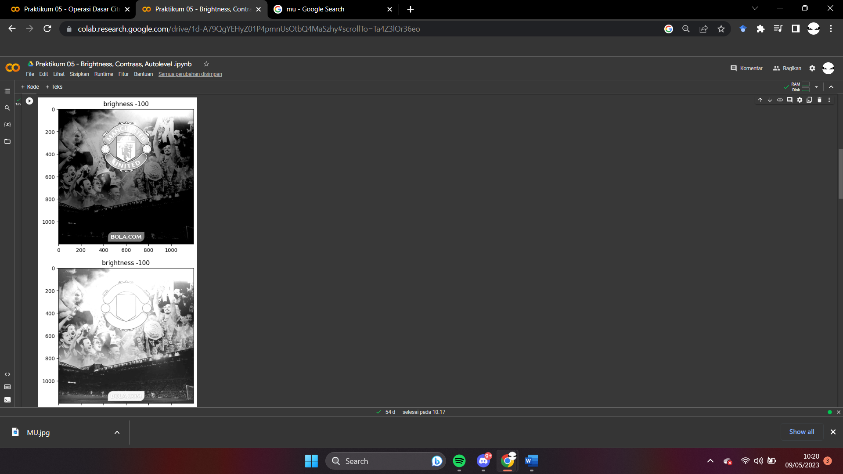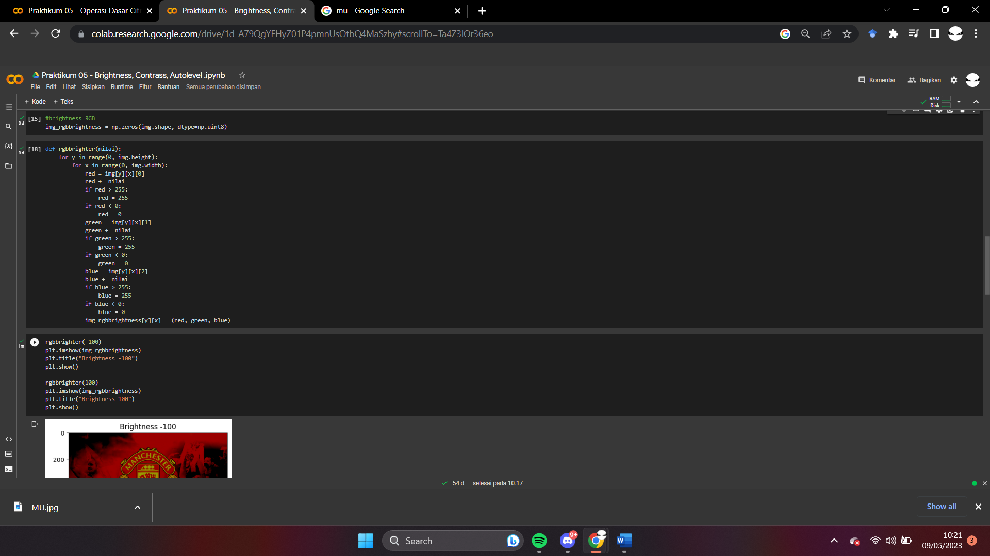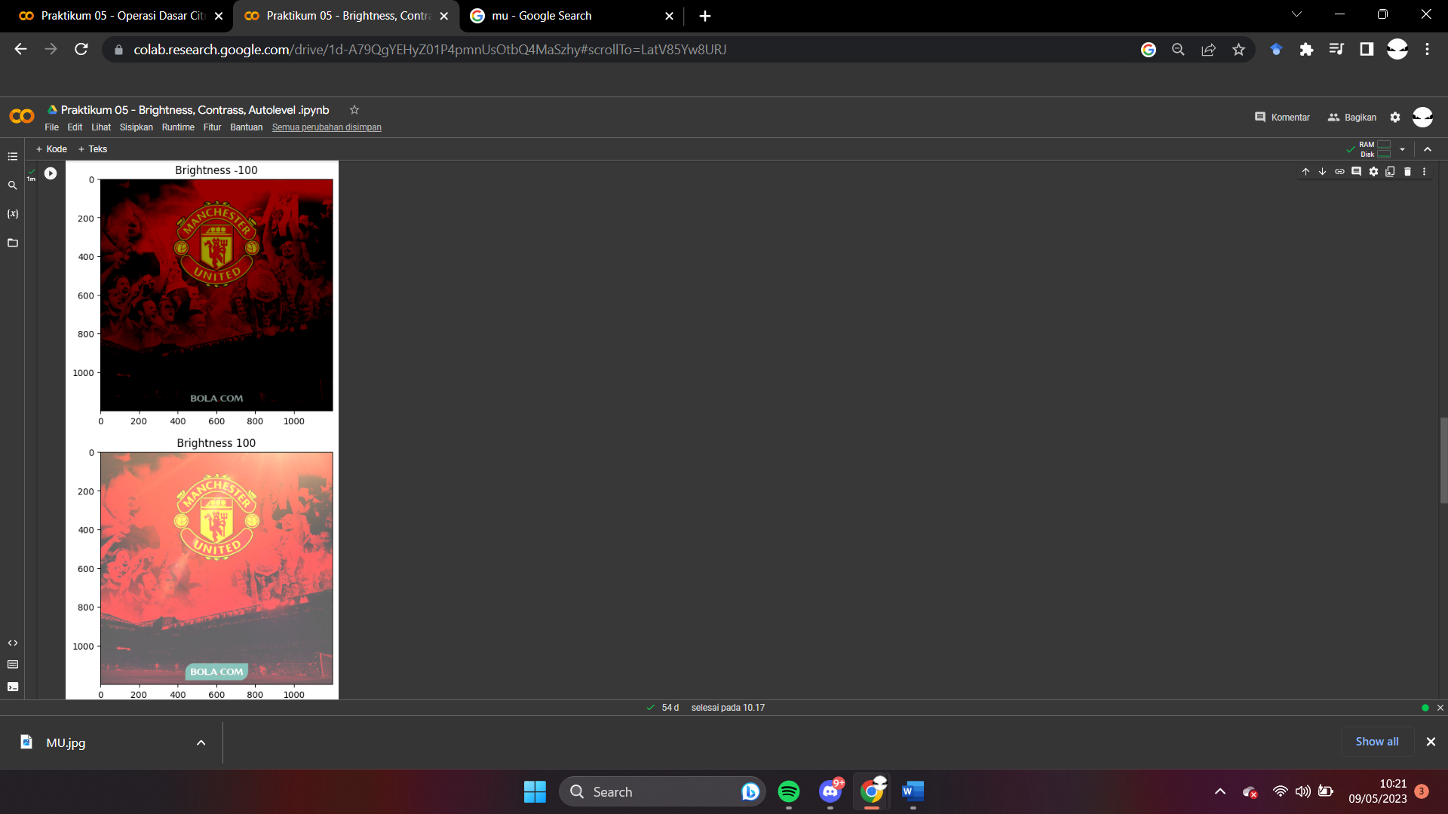

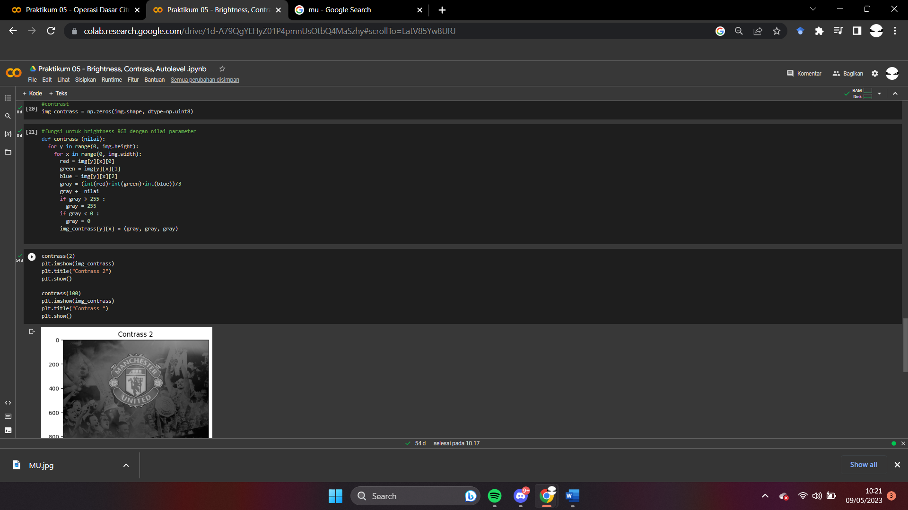

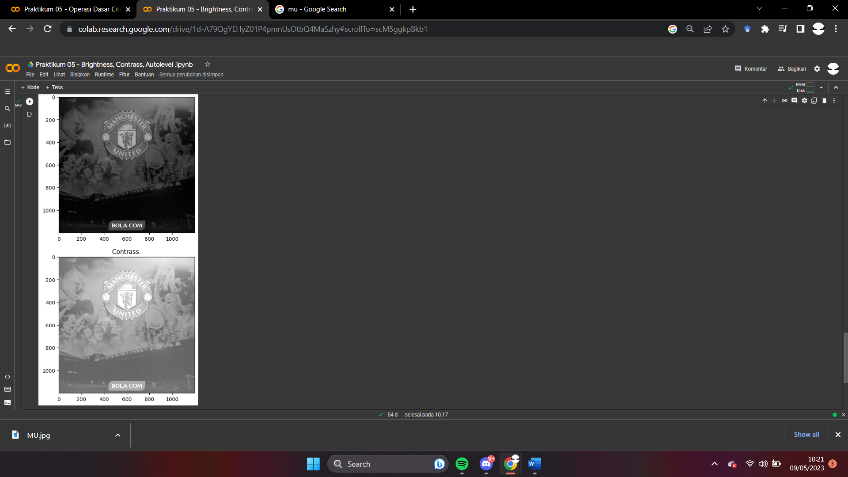

1. Praktikum 05 - Operasi Dasar Citra

